Laren Edwards

Math 404 Peer Review

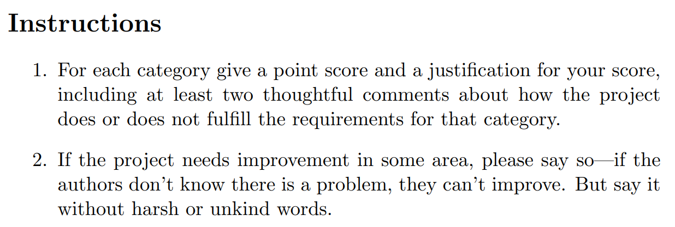

Score: 10/10

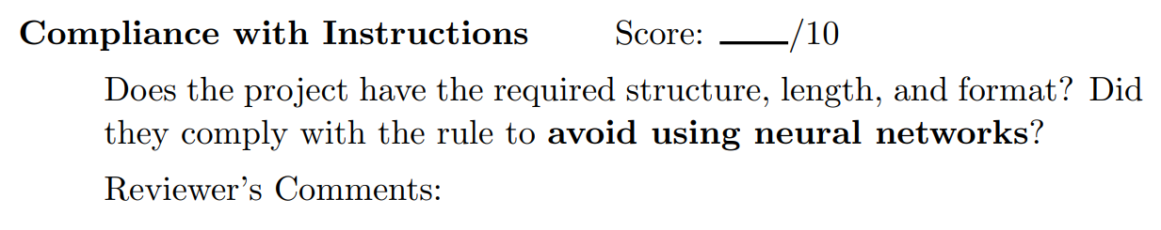

Excellent length and format. No neural networks used. Looks very professional.

Score: 10/10

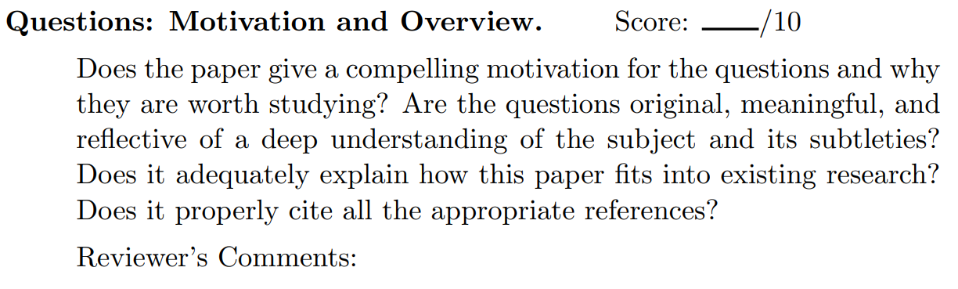

The questions were well posed and thoughtful. I’ve heard of similar things being done, but never with the strategies they used here. Based on the data transformations that were conducted, they understand music well.

Score: 10/10

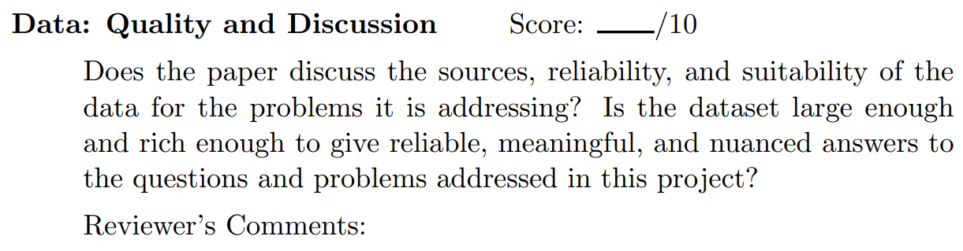

Yes, sources were well found and responsibly used. The dataset was big enough.

Score: 19/20

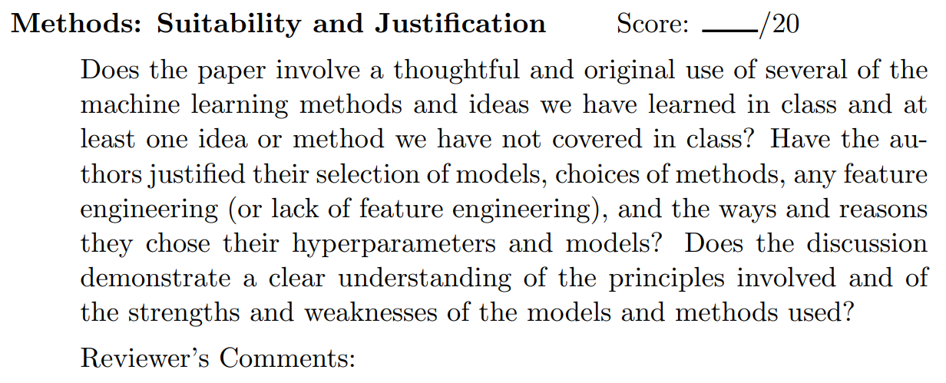

Yes, they used multiple methods and did a great job of explaining their processes. Discussion of state spaces and such were well thought out. Could use a little more explaining of why they expected particular models to work well for this problem.

Score: 23/25

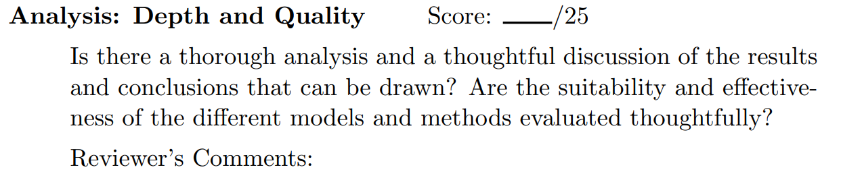

Analysis was great. Results were well analyzed and conclusions were well considered, in spite of the results being less than hoped for. I’d recommend expanding or cutting section 4.1.

Score: 15/15

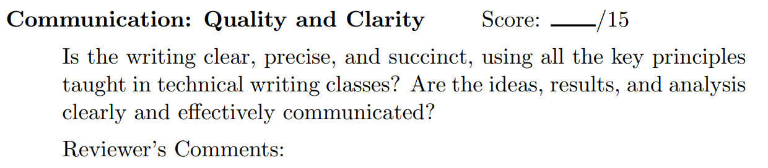

Excellent, accessible writing. Few grammar and spelling errors.

Score: 9/10

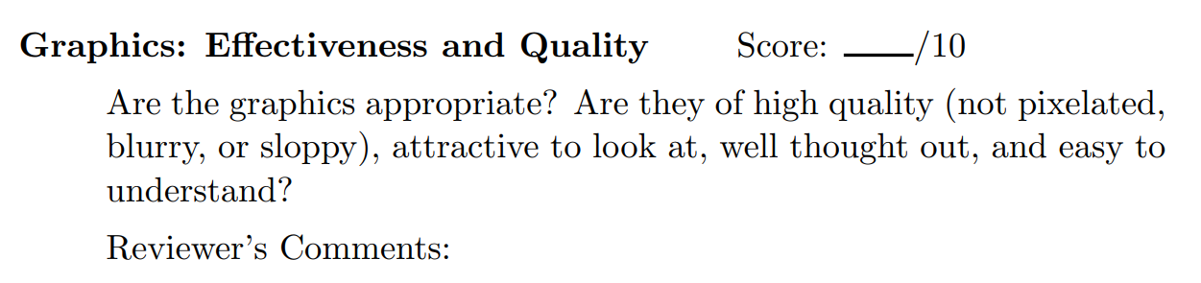

Graphics were well thought out and looked professional. Well labeled. I’d suggest doing a quick discussion of artifacts or good things in the sheet music example provided; it seems kind of out of nowhere.

Score: 10/10

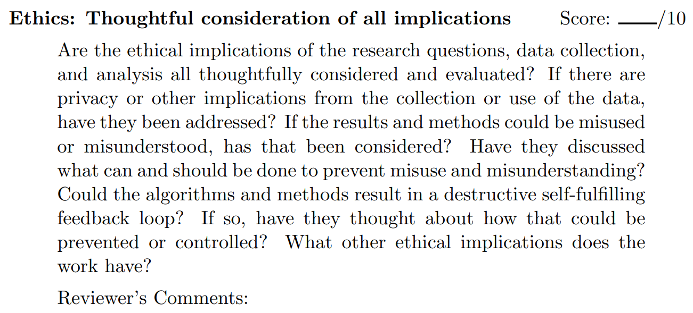

Great.

Score: 9/10

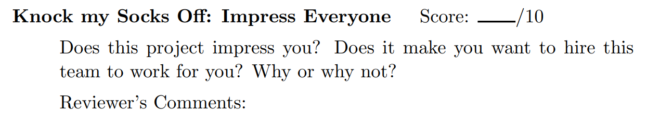

Problem and methods very well considered. Would get a 10/10 if it worked as well as hoped for!